

**COMP1108/COMP1181 – Project**

**Final Year Project Interim Report**

***Movie Rental Website***

|  |  |
| --- | --- |
| **Supervisor** | : Mr Kelvin Tan Kee Oon |
| **Student Name** | : Lim Wan Choon |
| **Student ID** | : 001045196 |
| **Student Email** | : [limwc1998@gmail.com](mailto:limwc1998@gmail.com) |

Contents

1. Current Situation 3

1.1 Research 3

1.2 Design 3

1.2.1 Class Diagram 3

1.2.2 Use Case Diagram 4

1.2.3 Entity Relationship Diagram 7

1.2.4 Data Flow Diagram 9

1.2.5 Sequence Diagram 14

1.3 Development 21

2 Problem Areas 21

3 Key Work for next period 21

4 Draft Content 21

5 Literature Review 22

# Current Situation

## Research

No extra research has been done.

## Design

### Class Diagram



Figure 1: Class Diagram

### Use Case Diagram



Figure 2: User Management use case diagram



Figure 3: Movie Management use case diagram



Figure 4: Rental Management use case diagram



Figure 5: Membership Package Management use case diagram



Figure 6: Payment Management use case diagram

### Entity Relationship Diagram

#### Conceptual

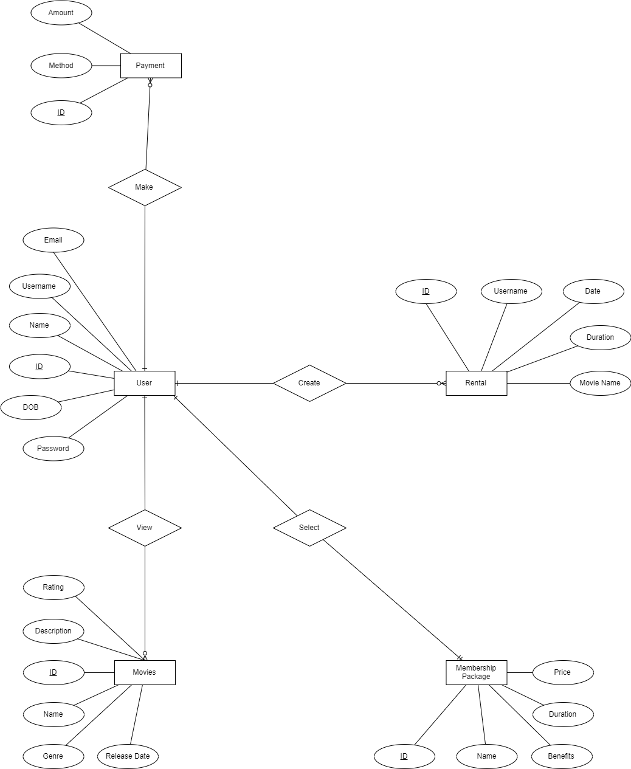

Figure 7: Conceptual Diagram

#### Logical

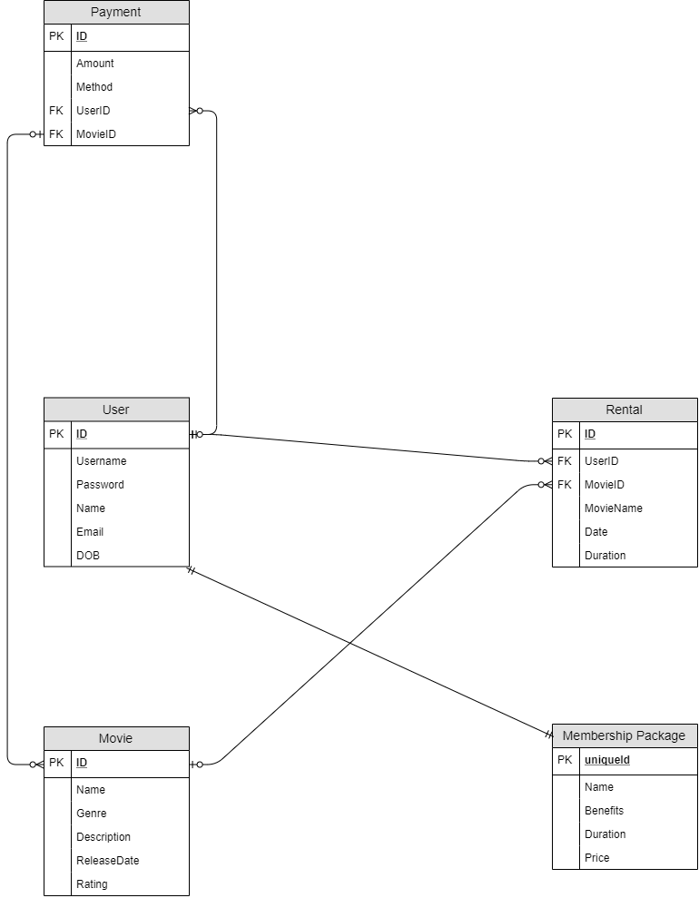

Figure 8: Logical Diagram

### Data Flow Diagram

#### Level 0



Figure 9: Level 0 DFD

#### Level 1



Figure 10: Level 1 (User, Membership Package, Payment)



Figure 11: Level 1 (Movie, Rental, Payment)

#### Level 2



Figure 12 : Level 2 (User, Membership, Payment)



Figure 13: Level 2 (Movie, Rental, Payment)

### Sequence Diagram

#### Login



Figure 14: Login Sequence Diagram

#### Edit Personal Information



Figure 15: Edit Personal Information Sequence Diagram

#### Change New Password



Figure 16: Change new password Sequence Diagram

#### 1.2.5.4 Movie, Rental, Payment



Figure 17: Movie, Rental, Payment Sequence Diagram

#### Membership Package



Figure 18: Membership Package Sequence Diagram

#### Add Movies



Figure 19 : Add Movies

#### Add Membership Package



Figure 20: Add Membership Package

## Development

No development has been done so far.

# Problem Areas

Some parts of the diagram require more time to figure out the correct flow.

# Key Work for next period

Development for the module will be done one by one.

# Draft Content

Chapter 1: Introduction

* 1. Brief Description of the system
  2. Problem Background
  3. Problem Statement
  4. Objectives

Chapter 2: Literature Review

2.1 Introduction

2.2 Key Phrase 1

2.3 Key Phrase 2

2.4 Key Phrase 3

2.5 Key Phrase 4

2.6 Key Phrase 5

2.7 Conclusion

Chapter 3: Review on Similar System

3.1 Introduction

3.2 System 1

3.3 System 2

3.4 System 3

3.5 Conclusion

Chapter 4: Requirement Analysis

Chapter 5: Design

5.1 Use Case Diagram

5.2 Class Diagram

5.3 Sequence Diagram

5.4 Data Flow Diagrams

5.5 Entity Relationship Diagram

Chapter 6: Development

6.1 Screenshots of systems and explanations

Chapter 7: Testing

7.1 Unit Test

Chapter 8: Conclusion

8.1 Conclusion

# Literature Review

No extra literature review has been done.